SIT123: Data Capture Technologies

# Lab Work Week 7: Data Visualization (30 marks)

In this task, we will design and develop visualizations for sensor data.

## 

## Due Date Friday 8:00pm, 9th September 2022

## Pre-requisites: You must do the following before this task

1. **Attend Class (Lecture) & Online Seminar**
2. **What following resources and videos on introduction to Tableau and how to build basic visualizations** (you might need to provide your details to be able to watch the videos)

<https://www.tableau.com/learn/tutorials/on-demand/tableau-interface>

<https://onlinehelp.tableau.com/current/guides/get-started-tutorial/en-us/get-started-tutorial-connect.html>

<https://www.tableau.com/learn/tutorials/on-demand/getting-started>

[https://www.analyticsvidhya.com/blog/2017/07/data-visualization-made-easy/](https://www.analyticsvidhya.com/blog/2017/07/data-visualisation-made-easy/)

1. **Read this sheet from top to bottom**

## Task Objective

**This is an individual task.** You will need to design and develop a visualization for the sensor data shared here:

<https://drive.google.com/file/d/1ResskTdqMN2Md770ICK99ehIWURBSsgz/view?usp=sharing>

<https://drive.google.com/file/d/1m8uRS9a7UOJrQn2mfCD_XYbF5AJo6JZH/view?usp=sharing>

## Software Required

* Tableau - Available in the lab

## Task Submission Details

There are 5 questions in this task. Answer all of them in this word document itself and submit to unit site.

### **Q1. What data types can you identify in the two data sets given? Use the information provided in the lecture, and identify the data types available in your datasets.**

(3 marks)

Dataset 1's nominal data in the'stamp' column was used to determine the data type. Numbers may be found in the "hum," "millis," and "datetime" columns. Data of the "hum" and "datetime" types are intervals. The information in'millis'is a ratio. Dataset 2 is comprised of nominal information derived from the stamp columns. All of the numbers in the'millis,' 'datetime,' and 'temp' columns are quantitative. "temp" and "datetime" information is of the interval type. The'millis'data set is a ratio.

### **Q2. Select one of the two data sets. Using your understanding of the given data, identify which visual variables are suitable to be used with your selected data set. Provide details of the visual variables and your justification here.**

(4 marks)

Mathematical information, often known as numerical data, is a specific kind of data that is conveyed by numerical representations rather than through words. To properly collect mathematical information, one must use a numerical framework, as the term implies. There are two types of data in mathematics: discrete data and continuous data. Both types may be utilised to find the right visual variable to pair with numbers.

The Quantitative Variable

For quantitative considerations, mathematic traits and estimate are key. The clinical model we've developed uses age as an example of a quantitative variable because of the many mathematical properties it might take on. Quantitative factors include, for example, height and weight.

To start, consider quantitative visual elements. Images with numerical values are used to display numerical data such as ranks, ranges, and percentages. The purpose of the quantitative visual variable is to illustrate the degree to which, or the need for, one substance is in comparison to another.

Images' relative relevance may be inferred by adjusting the visual variable's size. The volume of traffic along a roadway or the volume of water flowing through a canal are both indicators of the line's thickness, and hence, of the corresponding stream levels.

Value and saturation of the visual variable speak to varying degrees of detail or priority in an information value. You should prioritise either the saturation or the value of a colour, but not both. Various quantitative features are discussed, with a corresponding difference in immersion or value, and all are related to a single variable.

Again, the focal visual variable emphasises exposure to quantitative traits that might be exploited.

### **Q3. Design a visualization in Tableau to visualise one of the given data sets. Your visualization does not necessarily need to include all the visual variables you have listed in Q2. It should however be easy to understand, and have a clear message. Provide a screenshot of your visualization here.**

(10 marks)

### **Q4. Use the visualization in Q3 to provide some insights to the sensor data. Provide the discussion below.**

(5 marks)

### **Q5. Use your visualization knowledge to critique the given visualization below. Consider the following in your critique:**

* Who is the audience? (expert? non-expert?)
* What questions does this visualization answer?
* What design principles best describe why it is good / bad?
* Why do you like / dislike this visualization?
* Can you suggest any improvements?

#### Cattle herd – population changes in Australia (4 marks)

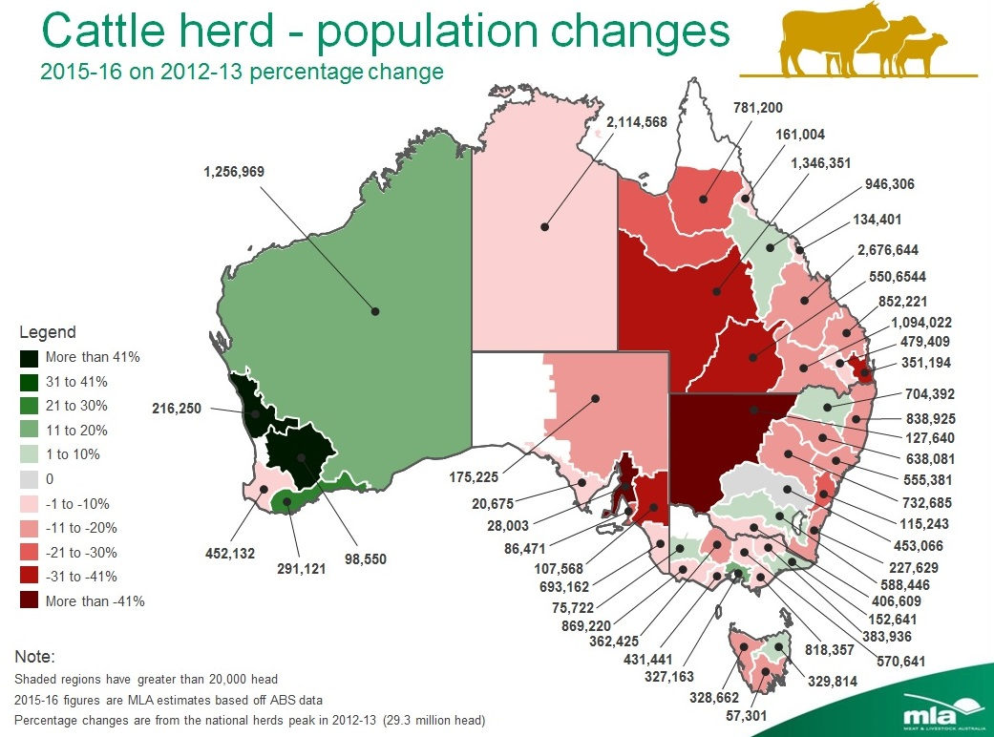

**Your Critique:**

Anyone interested in cattle farming or transportation in Australia is likely to find this infographic useful. Farmers, butchers, distributors (like Woolworths or Coles), and even some environmentalists might be considered stakeholders. This map clarifies not only the overall number of cattle in Australia, but also the growth and decline of the cow population in each state. Designing with different colours for each segment is a fantastic decision since it shows the audience where the increases and declines have happened in an easily understood pie chart. The decision to designate each portion with the total number of cattle in that region is both instructive and poorly designed. This makes it difficult to distinguish between different regions of Australia and makes the infographic difficult to read. On the other hand, without these figures, it would be impossible to have a clear picture of the total number of animals present. A modification that might be done to enhance this infographic is to replace the lines pointing to the smaller plots of land with numbers, and to add those numbers to a legend where the corresponding numbers reveal how many cattle are in that area. Here's an illustration of how the key would look: 1 - 102,2002 99,2333 250,334

#### b) Go to <http://covid-19-au.com> and check the interactive visualizations (4 marks)

**Your Critique:**

* Who is the audience? (expert? non-expert?)
* What questions does this visualization answer?
* What design principles best describe why it is good / bad?
* Why do you like / dislike this visualization?
* Can you suggest any improvements?